Sample Heading

**Main variable:**

The main variables are the association between density and level of evidence and density and level of evidence and age and level of evidence.   
  
So in the report please include an analysis of these variables.  
  
Let me know if that’s clear.

Hi Jon,  
  
Yes those are the figures and tables.  
  
Across all headings, the ones you are interested in are just in the statistical section and results. You don’t need to worry about either the conclusions or the other sections.  
  
The tables would be explained in the text, so if you read the paper there should be a description of the tables somewhere.  
  
Hopeit helps

Hi Jon,  
  
Here are further pointers.  
  
The paper that I sent you is just an inspiration. This does not need to be mentioned in the new project.  
  
Please describe what you have done and the relevant calculations, although this needs to be in the appendix.  
  
In the writing style you can be inspired by the paper I sent you in terms of tone.

Morning Jon,  
  
Hope you are well.  
  
I am attaching the details of the next project.  
  
The client wants to replicate the statistical analysis of the attached paper (Kruskal–Wallis test, Shapiro Wilk and Mann-Kendall test see statistics section) with the corresponding figures and tables, namely Fig. 2, Fig. 3 and Fig. 4 and tables 2, 3 and 4.   
  
As you can see that data has already been tabulated so it is just a matter of running the tests and drawing tables and graphs.  
  
The budget for this project is 450 pounds.   
  
Delivery its this Friday evening (even late evening its fine).  
  
Please let me know if you have any questions.

# Methods

## Eligibility criteria and the allocation of articles

## Data extraction

Where  is density,  is the number of citation and  is the time since publication we calculate the density as

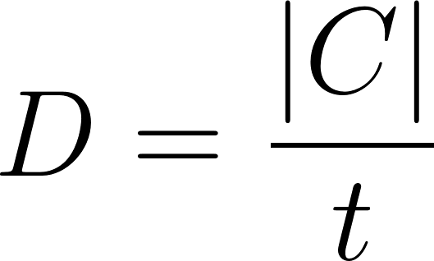

We can define 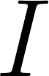 to be the **impact** a scientific paper has on its specific field by , the number of citations, such that 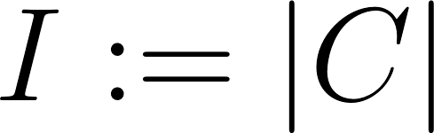.

**PRISMA**

**P**referred **R**eporting **I**tems for **S**ystematic Reviews and **M**eta-**A**nalyses

Year range: 1963-2014

## Statistical analysis

# Results

## Research area

## Level of evidence

## Article type

## Research institutions

## Further statistical analysis

# Discussion

# Conclusion

## Availability of data and material

## Financial support and sponsorship

## Conflict of interest

# References